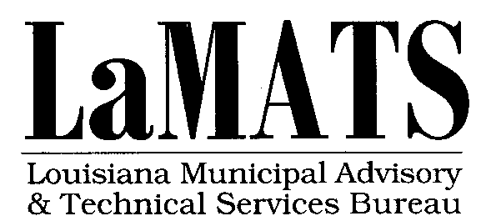 Municipal Debt Recovery Service

The Louisiana Municipal Advisory and Technical Services Bureau (LaMATS) was established in 1999 and is a wholly-owned subsidiary of the Louisiana Municipal Association. Its mission is simple…to bring economical and efficient services that assist the LMA membership with their day-to-day business. LaMATS is now offering a service to assist municipalities with the difficult task of recovering debt owed for past due utility bills, court fees, bonds, fines and warrants. The service is being offered at no-cost to the municipality, with the debtor being held responsible for all fees associated with the collection process.
- Interested municipalities and parishes can enter into a professional services agreement with LaMATS to pursue collection of all outstanding individual and corporate receivables.

- This is a turnkey delinquent accounts receivables management and collections program. It gives local government another important tool in the recovery of revenue owed by individuals and companies for services and fines levied by competent jurisdiction.

- Service is comprehensive and deploys the most sophisticated and modern techniques. It locates individuals through multiple skip tracing, certified notices, letter campaigns, and phone calls placed by qualified and well-trained professionals.

- All action taken on behalf of a municipality is documented (including call logs and recordings). This is made available to staff and local officials via a web-based, easy-to-navigate user portal, at no additional charge.

- Municipal officials can have confidence they are being represented in a respectful, polite, but serious and accurate way.

- High rates of return can be expected because of the expert ability to locate debtors, and provide several payment options.
- Municipalities are provided a model ordinance to adopt allowing for a 20% collection fee to be added to the debt.

- Monthly activity reports to include debtor contact information, payments (partial and full), status of each case and a complete invoice will make reconciliation easy.

LaMATS also offers a variety of other services and programs listed below:
- Insurance Premium Tax (IPT) Collection
- Occupational License Tax (OLT) Administration
- Delinquent Property Tax and Adjudicated Properties Sale
- Labor and Personnel Consulting
- Salary and Benefits Data
- Capital Outlay Consulting
- On-Line Grant Research Assistance
- Online Buyer’s Guide
- LSU Mobile Classroom

Please contact Cliff Palmer, Executive Director, (225) 316-7157 if you have any questions concerning these services.

